Math 1Name __________________________________ **2.3 - 2.5 Review** Date_________

Find the equation of the line that passes through the given points in slope-intercept form and point-slope form.

1. (3, 4) and (-2, 9) 2. (0, 5) and (3, 6)

3. (4, -6) and (10, 6) 4. (-2, 1.5) and (1, 3.6)

Write recursive and explicit formulas for the linear functions that are given in the following tables and graphs. Make sure to write your explicit formula completely simplified and in function notation.

|  |  |
| --- | --- |
| ***x*** | ***f(x)*** |
| 5 | 20 |
| 15 | 40 |
| 25 | 60 |
| 35 | 80 |

|  |  |
| --- | --- |
| ***x*** | ***f(x)*** |
| -1 | 8 |
| 0 | 5 |
| 1 | 2 |
| 2 | -1 |

5. 6.

***Recursive: Recursive:***

***Explicit: Explicit:***

Use the equations below to fill in the blanks and graph the lines.

7. 8.

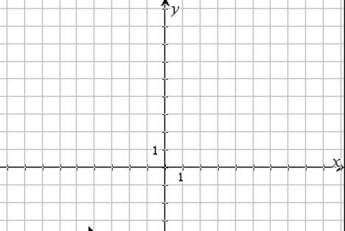 

 

Slope: _________________ Slope: _______________

Point: _________________ *y*-intercept _________________

*For questions 9 - 17, use the information given below.*

The homecoming committee spent $5000 for decorations, DJ, and other expenses. The cost per ticket is $40 a couple (no individual tickets are sold).

9. Write the rule showing how to calculate the profit ***P*** made in dollars if ***t*** is the number of tickets sold.

10. What is the independent variable? Why?

11. If the function is graphed, what is the y-intercept?

12. What does the y-intercept represent in the context of this problem?

13. Write the recursive formula for the profit based on the number of tickets sold.

14. If 500 tickets are sold, how much money will the Homecoming dance generate?

15. If only $1000 was made, how many tickets were sold?

16. Using the context of the problem above, explain what P(225) = 4000 means.

17. What are the practical domain and range?  
  
Domain: Range: